# Results Viewer

This project is to display results created by the distributed database simulator.

This project was not part of the simulator and was written with minimal effort and therefor does not follow programming best practices. I’m sorry.

A lot of work could be put into this to make it more user friendly.

This project can be downloaded from https://github.com/ChrisKay27/ResultsViewer

## Important notes

This project looks for the simulation results in a local database. It must (unless you want to change the DBConn class) be ran on the computer where the results are being stored.

For best results, when running experiments only vary two properties at once. This will allow these 2D line graphs to be useful. Varying three properties will require a 3D surface graph to properly view the results.

## How to use it

To use this project, take the experiment number generated when you run an experiment and put it into the experimentNumber variable in the main method of the class you want to use to produce the graph.

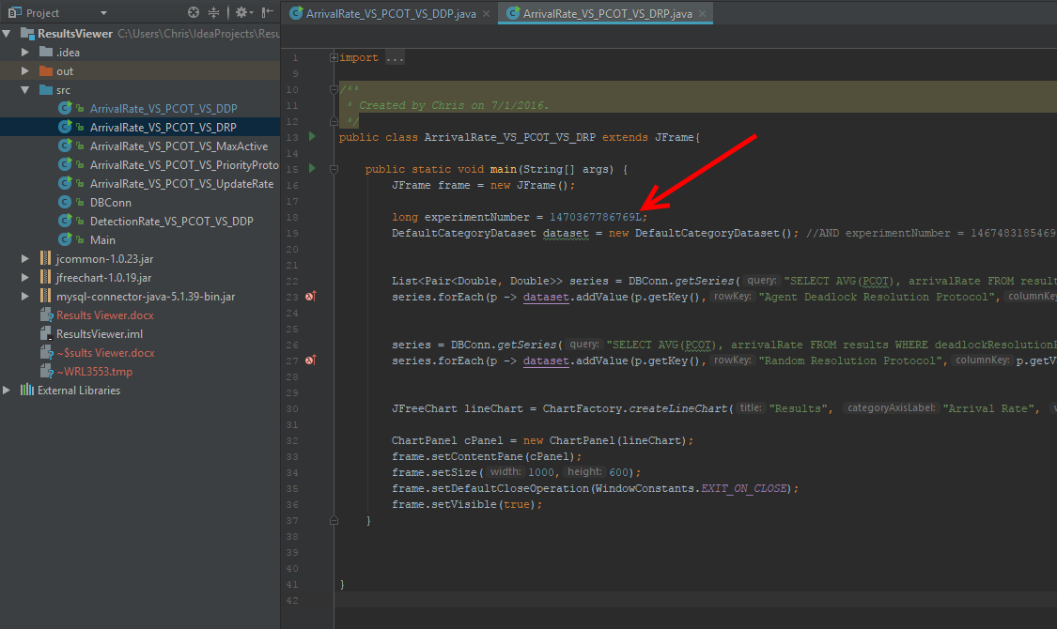

# Graphs

There is a class created to display a graph which compares two dimensions of the results. For example, the ArrivalRate_VS_PCOT_VS_DDP class compares arrival rate to deadlock detection protocol. The PCOT is the Y value.

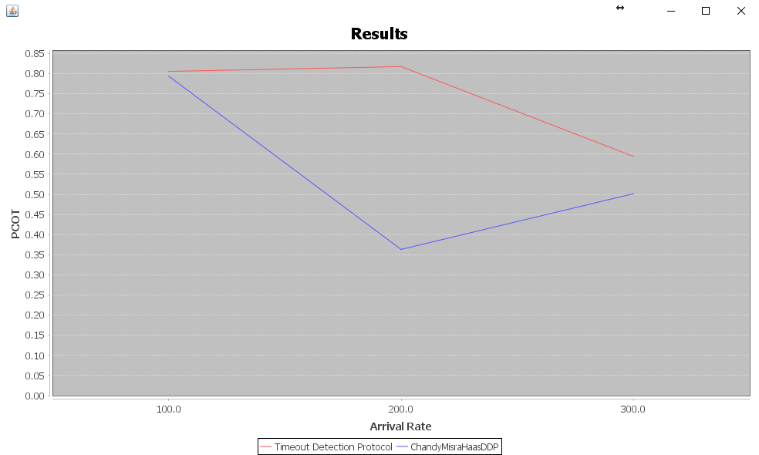

In this graph, the DDPs are the lines (each is its own series) and the arrival rate is the X-axis. To produce results that this specific graph can display you must have a variation on arrival rate and one on DDP (you need to have multiple values for each of these two properties. For example, the following params would produce a results that can be graphed with this class.

Topology:HyperCube   
NumPages:100   
ArrivalRate:100,200,300  
DDP:TimeoutDeadlockDetection,ChandyMisraHaasDDP  
DRP:AgentDeadlockResolutionProtocol   
PP:EarliestDeadlineFirst  
DetectionInterval:200  
MaxActiveTransactions:10

You will need to have at least 2 values for arrival rate because it is graphed on the X axis. If there is only one value for arrival rate the graph will not render properly (a line is defined by two points not one)

# Example

To view an Arrival Rate VS Update Rate experiment. Run an experiment with the following parameters.

LOGGING:false  
SEED:1  
Topology:HyperCube  
NumPages:100  
ArrivalRate:100,200,300 //This needs a variation for this graph  
DDP:AgentDeadlockDetectionProtocol   
DRP:FirstDeadlockResolution   
PP:EarliestDeadlineFirst  
DetectionInterval:200  
MaxActiveTransactions:10  
AgentsHistoryLength:3   
UpdateRate:0,.25,.5 //This needs a variation for this graph

Put your experiment number into the ArrivalRate_VS_PCOT_VS_UpdateRate class and right click and run this class.

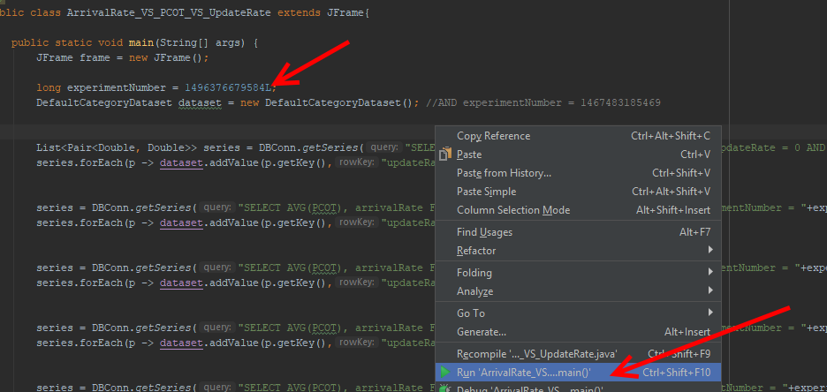

You should get a graph that looks like the following

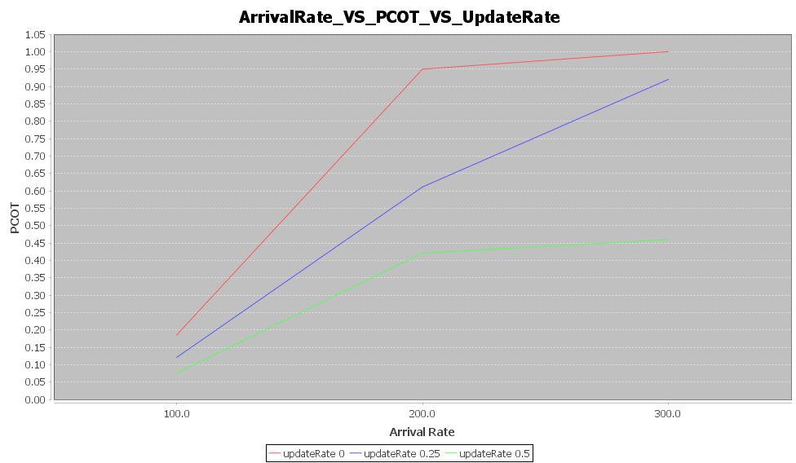he